Church of the Blessed Sacrament Viale Europe

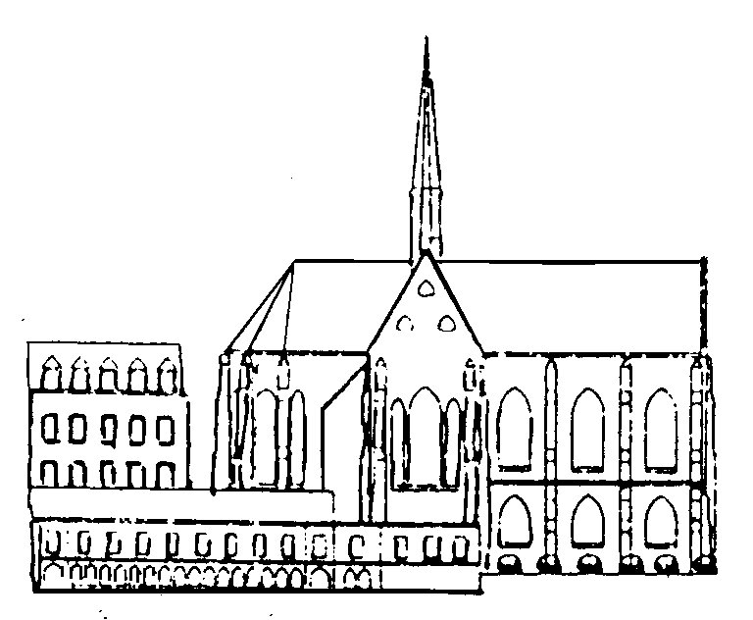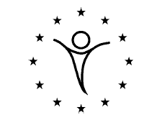

INVITATION

« They presented these men to the apostles,
who prayed and laid their hands on them » (Acts 6:6)

The Communion of Viale is happy to invite you to the ordination to the diaconate of

Liju Augustin Kachappilly and Benoît Bouchard
by Archbishop of Malines Brussels, André-Joseph Léonard,

and invites you to attend the celebration or to remain in communion with prayers

Mr & Mrs Kachappilly are happy to inform you that their son Liju Augustin will be ordained to the diaconate by Archbishop of Malines Brussels, André-Joseph Léonard, and invite you to attend the celebration or to remain in communion with prayers
Anapara manjapra683581 kerala India, anand.liju@yahoo.com

You are cordially invited to the friendly meal which will follow
Sunday, September 2, 2012 at 5:30 PM
Church of the Blessed Sacrament - La Viale Europe 205 Chaussée de Wavre, 1050 Brussels, Belgium. near the European Parliament and the railway station Brussels Luxembourg
A la louange de Dieu Père, Fils et Saint-Esprit,

Monsieur et Madame Bouchard sont heureux de vous faire part de l’ordination diaconale de leur fils

Benoît

par Monseigneur André-Joseph Léonard,
Archevêque de Bruxelles-Malines

Le 2 septembre 2012 en l’Eglise des Pères du Saint-Sacrement de Bruxelles
Et de vous prient de vous unir à la joie de l’Eglise en ce jour de fête

« On les présenta aux apôtres et, après avoir prié, ils leur imposèrent les mains».
Actes de Apôtres, 6,6

